Book Shop



Beenish Qadir

2018-KIU-5524

&

Rahila

2018-KIU-5535

BookShop

BY

Beenish Qadir

2018-KIU-5524

&

Rahila

2018-KIU-5535

A project submitted in partial fulfillment for the degree requirement of

BS Software Engineering

Department of Computer Science KIU, Gilgit.

In the Name of Allah Almighty the Most Beneficent and

The Most Merciful

**CERTIFICATE**

This is to certify that the project entitled **“**BS**”** submitted by **Beenish Qadir (2018-KIU-5532) & Rahila (2018-KIU-5532)** in fulfillment of the requirements for the award of Bachelor of Science in Computer sciences at the Karakoram International University Gilgit is an authentic work carried out by them under my supervision and guidance. To the best of my knowledge, the matter embodied in the thesis has not been submitted to any other University/ Institute for award of any Degree or Diploma.

Thesis Supervisor ____________________

(Miss. Ponam almas)

Chairperson/Chairman/HOD ____________________

(Dr. Zarnawab Khan Swati/HOD)

External Examiner ____________________

(External Examiner)

**DEDICATION**

First and foremost, we devote this humble effort to God Almighty, who is our originator, our strong foundation, and our source of knowledge and comprehension. We also dedicate this work to our loving parents, all of our honorable teachers, all of whom have been a constant source of encouragement and motivation for us and whose love, warmth, support, and guidance have enabled us to complete this project.

# DECLARATION

I hereby declare that this Project is a presentation of our own work and that it has not been submitted anywhere for any award. I also warrant, that I have not received outside materials or involved the external contributions, if received/involved I shall acknowledge in written statement to authorities, otherwise I shall be liable for the cancellation of my project thereby the degree that will be awarded.

|  |  |
| --- | --- |
| Signature  Scholar Name: ____________________  Reg: ____________________________  Date:____________________________ | Signature  Supervisor: ______________________  Name: __________________________  Date: ____________________________ |

# ACKNOWLEDGMENT

All praises are for Almighty ALLAH, who blessed us with courage to copy with the odds of life and enabled me to complete this project work. I wish to extend my gratitude to the facility of Karakorum International university and to the teachers of computer science department in particular invaluable guidance and advice had enable me to achieve goal during my study at this establishment. we would also like to admit this project to all of supporters.

I am very grateful to Miss Ponam Almas (Project Supervisor) for his innumerable recommendation, and guideline comment and moral support for complete this project. my thanks go to respected supervisor Sir Ismail department of computer science who made me self-confidence to complete task in the time. I have to appreciate those teachers who worked on our personal skill in last four years.

Thank you.

# *ABSTRACT*

The web app 'BookShop' is an intuitive and user-friendly platform designed to facilitate online book purchasing for customers and streamline book management for shopkeepers (admins). With a focus on simplicity and efficiency, the app allows shopkeepers to add and categorize books, set prices, and manage their inventory, while customers can easily browse, select, and purchase books through a convenient shopping cart feature.

For shopkeepers (admins), 'BookShop' provides a comprehensive backend system that empowers them to add new books to their inventory with relevant details such as book title, author, description, and cover image. They can categorize books into different genres, subjects, or classes, making it easier for customers to find the books they are interested in. The app also allows shopkeepers to set and modify book prices to ensure accurate and up-to-date pricing information.

Furthermore, 'BookShop' provides shopkeepers with the ability to manage their inventory efficiently. They can update book availability status, mark books as out of stock, or remove discontinued products, ensuring customers have access to the latest and most relevant book selection.

On the customer-facing side, the 'BookShop' web app offers an appealing and easy-to-navigate interface that enables users to browse through the available books effortlessly. Customers can search for specific books, explore categories, and access detailed book information, including author bio, book synopsis, and customer reviews.

The shopping cart functionality allows customers to add desired books to their cart, review their selections, and make modifications before proceeding to the checkout process. During checkout, customers can securely complete their purchases by entering payment and shipping details.

In summary, the 'BookShop' web app bridges the gap between shopkeepers and customers, providing a seamless platform for online book shopping. Shopkeepers can easily manage their book inventory and pricing, while customers can browse, select, and purchase books through a user-friendly interface. With its efficient features and robust functionality, 'BookShop' aims to enhance the book shopping experience for all users and promote the joy of reading in the digital age.

.



Book Shop (2018-2022)

Table of Contents

DECLARATION vi

ACKNOWLEDGMENT vii

*ABSTRACT* viii

ACRONYMS xiii

Chapter 1 14

INTRODUCTION 14

Chapter 2 19

REVIEW OF LITERATURE 19

Chapter 3 20

REQUIREMENT SPECIFICATION 20

3.1 Introduction 20

3.2 Functional requirements 20

3.3 Non-functional requirements 22

Chapter 4 25

DESIGN 25

4.3.1 Flowchart 27

4.3.5 Data Flow Diagram 32

Chapter 5 37

SYSTEM IMPLEMENTATION 37

Chapter 6 41

SYSTEM TESTING AND EVALUATION 41

6.2 Create New Account 42

CHAPTER 7 51

CONCLUSION 51

Future Work 52

REFERENCES 53

**List of Figures**

**FIGURE 4.1 FLOWCHART**....................................................................................................................... 28

**FIGURE 4.2 SEQUENCE DIAGRAM** ......................................................................................................... 30

**FIGURE 4.3 USE CASE DIAGRAM** .......................................................................................................... 31

**FIGURE 4.4 ENTITY RELATIONSHIP DIAGRAM** .................................................................................... 32

**FIGURE4.5 DATA FLOW DIAGRAM: LEVEL 0** ....................................................................................... 34

**FIGURE4.6 DATA FLOW DIAGRAM: LEVEL 1** ....................................................................................... 36

**FIGURE 6.1 USER LOGIN** ....................................................................................................................... 41

**FIGURE 6.2 CREATE NEW ACCOUNT** ................................................................................................... 42

**FIGURE 6.3 ADD CATEGORY** ........................................................................................................... 43

**FIGURE 6.4 ADD PRODUCT** ...............................................................................................................44

**FIGURE 6.5 ADD TO CART** ................................................................................................................ 45

**FIGURE 6.6 MANAGE ORDER** .......................................................................................................... 46

**FIGURE 6.7 PROFILE**............................................................................................................................46

**List of Tables**

**TABLE 3. 1 FR Table**............................................................................................................................ 24

**TABLE 6.1 LOGIN**.............................................................................................................................. 47

**TABLE 6.2 SELECT CATEGORY**.................................................................................................... 48

**TABLE 6.3 SEARCH BY CATEGORY** ............................................................................................ 48

**TABLE 6.4 ADDING PRODUCT** ...................................................................................................... 49

**TABLE 6.5 ADD TO CART**................................................................................................................ 49

**TABLE 6.6 SHOW BOOK DETAILS**................................................................................................ 50

# ACRONYMS

KIU Karakoram International University

BS Book Shop

GUI Graphic user Interface

ERD Entity Relationship Diagram

IDE Integrated Development Environment

SDK Software Development Kit

# Chapter 1

## INTRODUCTION

Web App 'Book Shop,' an innovative and user-friendly online platform that redefines the way we experience books. This web-based application is designed to provide both bookstore owners and customers with a seamless and efficient book management and buying experience. For bookstore owners, 'Book Shop' streamlines inventory management, categorization, and pricing, enabling them to offer a diverse collection of titles. Meanwhile, for customers, the platform offers an extensive catalog of books, complete with author profiles, reviews, and personalized recommendations, ensuring an immersive journey through the world of literature. Embrace the future of book buying and selling with 'Book Shop' as we connect readers and bookstores like never before.

#### 1.1 Background of Proposed System

Book Shop' stems from the rapidly changing landscape of the book industry, where the traditional brick-and-mortar bookstores are facing increasing challenges due to the digital revolution and changing consumer behavior. Customers today are seeking convenience, variety, and personalized experiences when it comes to buying books. The emergence of e-commerce giants and online book retailers has reshaped the way people purchase books, leading to a decline in foot traffic to physical bookstores. In response to this shift, the 'Book Shop' system is conceived to bridge this gap by providing an intuitive and efficient online platform for bookstore owners to adapt to the digital age, expand their reach, and offer a diverse collection of books, while meeting the evolving needs of the tech-savvy readers.

Moreover, the proposed system recognizes the importance of leveraging data-driven insights to stay competitive and relevant in the modern book market. By incorporating data analytics and reporting tools, the 'Book Shop' system empowers bookstore owners with valuable market trends, customer preferences, and performance indicators. This data-driven approach enables them to optimize their book inventory, pricing strategies, and marketing efforts, ensuring a seamless and personalized shopping experience for customers. With a focus on enhancing the synergy between bookstores and readers, the 'Book Shop' system aspires to revitalize the book industry, reinvigorate the joy of reading, and foster a stronger bond between book enthusiasts and the literary world.

#### 1.2 Overview

'BookShop' is an innovative and user-friendly online platform that revolutionizes the book buying experience. This comprehensive web-based application caters to both bookstore owners and customers, providing a seamless and efficient book management system for owners while offering a diverse and captivating collection of books for readers. With its intuitive backend, bookstore owners can effortlessly add, categorize, and set prices for books, enabling them to keep their inventory up-to-date and organized. On the customer side, 'BookShop' offers an extensive catalog of books across genres, accompanied by author profiles, reviews, and personalized recommendations, creating an immersive journey through the world of literature. Through a perfect blend of technology, data-driven insights, and personalized experiences, 'BookShop' bridges the gap between traditional bookstores and the digital world, redefining the way books are bought, sold, and cherished by book enthusiasts worldwide

#### 1.3 Aim of Proposed System

The aim of the proposed system, "Book Shop," is to develop a user-friendly and efficient MVC (Model-View-Controller) web application that facilitates the online selling of books. The primary objective is to create a platform where both the admin and customers can seamlessly interact and carry out their respective tasks with ease.

For the admin, the system will offer convenient product management features. This means that the admin will be able to easily add new books to the online store, update book information such as details, descriptions, and cover images, and also have the flexibility to adjust book prices as needed. Additionally, the admin will have the ability to organize books into various categories, making it easier for customers to find their desired books effortlessly.

For the customers, the proposed system will provide a smooth and enjoyable book shopping experience. Customers will be able to browse through a diverse selection of books based on different categories, ensuring they can find books that match their interests and preferences. The system will display comprehensive information for each book, including the title, author, description, price, and cover image, enabling customers to make well-informed decisions before making a purchase. Furthermore, the system will allow customers to add their chosen books to the cart and seamlessly place orders, streamlining the entire checkout process for a hassle-free shopping experience.

Overall, the "Book Shop" web application aims to create a user-friendly interface for both the admin and customers, making it a delightful experience for all users involved. By adopting the MVC architecture, the system will be well-organized and scalable, ensuring it can effectively meet the demands of an online book-selling business while providing a pleasant and efficient shopping platform for customers.

#### 1.4 Problem Statement of Proposed System

The problem addressed by the proposed "Book Shop" web application arises from the absence of a streamlined and user-friendly platform for selling books online. The current scenario lacks an efficient system that caters to both the admin and customers' needs effectively. Admins face challenges in managing the product inventory, updating book information, and setting prices in a convenient manner. Additionally, organizing books into categories is a cumbersome process, leading to an inefficient browsing experience for customers. On the customer's side, there is a lack of a cohesive and easy-to-use interface for browsing books based on their interests. The absence of detailed book information hinders customers' ability to make well-informed purchasing decisions. Moreover, the checkout process is often complicated and time-consuming, deterring potential buyers from completing their orders. Overall, the existing limitations in the current book-selling process highlight the pressing need for the "Book Shop" web application to address these challenges and provide a seamless and satisfactory online book shopping experience for all users involved.

#### 1.5 Advantage of proposed System

Following below are advantages of proposed system

1. User Friendly Interface

2. Efficient Product Management.

3. Secure Payment Processing

4. Possibility of more revenue and business growth.

#### 1.6 Product Functions / Features

The "Book Shop" project encompasses a wide range of features designed to create a comprehensive and efficient online book-selling platform. Some of the key features of the project include:

1. **User Registration and Authentication:** The application allows users to register and create accounts, enabling them to log in securely. This feature ensures personalized experiences and access to user-specific information.
2. **Book Browsing by Categories:** Customers can browse books conveniently based on various categories, genres, authors, or subjects. The system's categorization makes it easy for users to find books of their interest quickly.
3. **Detailed Book Information:** Each book listing provides comprehensive details, including the title, author, description, cover image, and price. This information helps customers make informed decisions before making a purchase.
4. **Shopping Cart:** Customers can add desired books to their shopping cart, allowing them to review and manage their selections before proceeding to the checkout process.
5. **Secure Checkout and Payment Processing:** The application offers a secure checkout process with multiple payment options, ensuring the safe handling of customer payment details and seamless transaction completion.
6. **Admin Panel:** The system provides a dedicated admin panel accessible to authorized administrators. From the admin panel, administrators can manage product inventory, add new books, update book details, and categorize books for efficient organization.
7. **Order Management:** The admin panel allows administrators to track and manage customer orders, ensuring timely processing and delivery.
8. **Search Functionality:** Customers can utilize the search feature to find specific books by titles, authors, or keywords, enhancing the overall browsing experience.
9. **User Account Management:** Customers can edit their profile information, update preferences, and review past orders, enhancing their overall engagement with the platform.
10. **Responsive Design:** The application is built with a responsive design, ensuring optimal performance and user experience across various devices, including desktops, tablets, and smartphones.
11. **Security Measures:** The system incorporates robust security measures to safeguard user data and ensure a secure shopping environment.

# Chapter 2

## REVIEW OF LITERATURE

The Book Store Management System is meticulously crafted to cater to customer inquiries concerning a diverse array of books. This cutting-edge online platform seamlessly matches customer queries with information stored in a centralized database, encompassing author details, publishers, book titles, prices, latest updates, storage information, upgrades, and more. By reducing the need for customers to fill out forms and provide book information during the check-in process, the system enhances customer satisfaction. Swift access to book history empowers customer service representatives to recommend periodic maintenance services and promptly provide information on available parts for different publications, all while respecting the customers' valuable time. Such elevated service levels foster heightened customer loyalty.

The allure of online shopping today lies not only in its convenience but also in its extensive product selection, highly competitive prices, comprehensive product information (including customer reviews), and user-friendly navigation for effortless product searches. Additionally, the appeal of online shopping is further amplified by the cost-effectiveness for business owners, who can offer products at more competitive rates due to reduced overhead expenses compared to running physical stores. Moreover, by embracing online shopping, businesses gain access to a global market, attracting diverse customers from various ethnic backgrounds, thereby augmenting customer value and ensuring sustainable marketing practices.

The primary objective of this project is to develop an intuitive web-based interface, enabling users to easily search for products, access comprehensive product descriptions, and place orders effortlessly. The implementation of a sophisticated search engine facilitates swift and convenient product searches tailored to users' specific needs. By listing a set of products based on the search term and empowering users to filter results using various parameters, this search engine ensures a streamlined and personalized shopping experience for every customer

# Chapter 3

## REQUIREMENT SPECIFICATION

### 3.1 Introduction

### In the realm of Requirement Specification, the Book Shop MVC Project takes center stage as an innovative online platform dedicated to selling school books. As the most crucial and initial stage of software development, Requirement Analysis becomes the cornerstone of our project's success. Understanding the precise requirements is paramount, as the functionalities of every program or application rely heavily on this stage. By thoroughly examining and comprehending these requirements, we aim to create a seamless and usable system that empowers administrators to effortlessly add school books and set competitive prices. This user-friendly interface ensures a streamlined shopping experience for students and parents, revolutionizing the way educational resources are accessed and acquired. Join us on this transformative journey, where education and technology converge, and Requirement Specification serves as the catalyst for an exceptional online school book selling platform.

### 3.2 Functional requirements

The Book Shop web application is designed with a set of functional requirements to ensure a seamless and enriching user experience. Firstly, it should allow users to register and log in securely, enabling them to create personalized profiles and access features tailored to their preferences. The application's key functionality lies in the efficient management of the book catalog, giving the admin the ability to add, update, and delete books, including essential details like titles, authors, publishers, genres, and prices. To enhance user convenience, a comprehensive search and filter feature must be implemented, empowering users to easily locate their desired books based on various criteria. A well-designed shopping cart and checkout process should enable customers to review their selections and complete purchases securely. Additionally, the application should offer order tracking, ensuring customers receive timely updates on their purchases until successful delivery.

To ensure efficient store management, the admin should have access to a user-friendly dashboard. This dashboard should provide insights into order status, inventory levels, sales reports, and customer feedback. Furthermore, the application should facilitate user interaction by allowing customers to leave reviews and ratings for books they have purchased, aiding other users in making informed decisions. To facilitate smooth and secure transactions, the application should integrate with reliable payment gateways. User notifications play a crucial role in keeping customers engaged, with the system sending timely updates on order status, promotional offers, and other relevant information via email or in-app alerts. Finally, customers should be empowered to manage their accounts, allowing them to update information, manage email preferences, and request account deletion if necessary. By adhering to these functional requirements, the Book Shop web application aims to create a seamless and delightful shopping experience for book enthusiasts of all ages.

The table labeled 3.1 presents the functional requirements of the Book Shop corresponding to each functionality requirement.

**Table 3.1: FR Table**

|  |  |
| --- | --- |
| **Section/**  **Requirement ID** | **Requirement Definition** |
| FR 1 | Admin should be able to signup |
| FR 2 | Admin should be able to login |
| FR 3 | Admin should be able to create profile |
| FR 4 | Admin should be able to add Category |
| FR 5 | Admin should be able to add Class |
| FR 6 | Admin should be able to add Product |
| FR 7 | Admin should be able to edit Category |
| FR 8 | Admin should be able to edit Class |
| FR 9 | Admin should be able to edit Product |
| FR 10 | Admin should be able to delete Category |
| FR 11 | Admin should be able to delete Class |
| FR 12 | Admin should be able to delete Product |
| FR 13 | Admin should be able to edit profile |
| FR 14 | Admin should be able to manage order |
| FR 15 | Admin should be able to search books by categories. |
| FR 16 | Admin should be able to place order |
| FR 17 | Admin should be able to logout |
| FR 18 | Admin should be able to check cart |
| FR 19 | User should be able to signup |
| FR 20 | User should be able to login |
| FR 21 | User should be able to create profile |
| FR 22 | User should be able to edit profile |
| FR 23 | User should be able to manage order |
| FR 24 | User should be able to search books by categories. |
| FR 25 | User should be able to increase number of items |
| FR 26 | User should be able to see summary of his order |
| FR 27 | User should be able to pay amount |
| FR 28 | User should be able to see his order status |
| FR 29 | User should be able to logout |

### 3.3 Non-functional requirements

The Book Shop should also meet various non-functional requirements to quarentee a favorable user experience. These might encompass

#### 3.3.1 Performance

The bookshop’s website should load within 2 seconds to ensure quick access for users

##### 3.3.2 Scalability

The system should be able to handle a growing number of visitors during peak times, such as After School result times.

##### 3.3.3 Reliability

The inventory database should have a 99.9% uptime, minimizing any downtime that could impact customers’ ability to browse and purchase books.

##### 3.3.4 Usability

##### The User interface should be intuitive and easy to navigate, catering to customers of various technological proficiency.

##### 3.3.7 Response time

##### The System should provide timely feedback to user actions, such as adding items to the cart or completing a purchase.

##### 3.3.8 Security

User data, including personal and payment information is encrypted and stored securely to prevent unauthorized access.

#### 3.4 Required Tools and Technologies

The list provided below outlines the essential tools and technologies needed for the bookshop.

##### 3.4.1 Hardware Specification

The hardware specifications for the bookshop encompass a diverse range of essential components, prominently featuring systems equipped with web browsing capabilities. These systems serve as the primary interface for running the online application, enabling customers to seamlessly explore the digital storefront, peruse book offerings, and complete transactions. Additionally, these browsing-enabled systems play a crucial role in upholding the underlying Model-View-Controller (MVC) architecture, facilitating user interactions with the View and Controller layers. Their integration ensures both a user-friendly experience for customers and efficient management of inventory, orders, and overall operations by employees, underscoring the bookshop's commitment to a seamless online shopping experience.

##### 3.4.2 Software Requirement

In order to facilitate the operation of the bookshop, a crucial software requirement revolves around the accessibility of a web browser. This pivotal component enables the bookshop's functionality to seamlessly unfold within the realm of any software that encompasses a web browsing capability. By adhering to this fundamental need, the bookshop ensures its compatibility with a diverse array of platforms, ranging from conventional desktop applications to modern mobile devices. This adaptability not only grants customers the freedom to explore and engage with the bookshop's offerings at their convenience but also affords the establishment a broad reach, transcending various software environments. The capability to harness the power of a web browser becomes the cornerstone that underpins the bookshop's online presence, facilitating a user-centric experience while enabling effective book browsing, selection, and purchase activities, irrespective of the software landscape in which it is accessed.

##### 3.4.3 Technologies

The Technologies used in Book Shop Are Visual studio 2022 and SSMS.

# Chapter 4

## DESIGN

#### 4.1 System Architecture

The system architecture for the bookshop revolves around a client-server model, encompassing the following integral components

1. **Client-side:** This component encompasses the online bookshop's user interface, accessible through web browsers on various devices such as desktops, laptops, tablets, and smartphones. Users can explore the book catalog, search for specific titles, view book details, and proceed with purchases. Additionally, the client-side allows customers to manage their accounts, track orders, and engage in interactive features. This user-centric interface ensures a seamless and engaging experience for book enthusiasts
2. **Server-side:** The heart of the architecture resides in the server-side infrastructure, responsible for hosting and managing the bookshop's operations. This layer involves the deployment of web servers, application servers, and associated technologies that handle user requests, process transactions, and manage data interactions. It supports the dynamic generation of web pages, enforces security measures, and ensures efficient communication between clients and the underlying database.
3. **Database**: The database serves as the repository for crucial data that fuels the bookshop's functionality. It stores comprehensive information about books, including titles, authors, genres, descriptions, prices, and availability. Furthermore, user-related data, such as customer profiles, order histories, and preferences, are securely stored within the database. This robust storage system facilitates seamless searching, efficient order processing, and personalized user experiences.

#### 4.2 Design Methodology

The Mazdoor app's design methodology is a critical aspect of developing effective software. There are various design approaches, including the waterfall model, which follows a sequential top-to-bottom approach, and the agile model. These models offer different strategies for software development that aim to create useful systems and software that can be easily modified by developers. By selecting an appropriate design methodology, I can ensure that the software is efficient, reliable, and flexible enough to adapt to changing user needs and requirements.

##### 4.2.1 Agile Development Model

The development of the bookshop is based on the Agile development model. This iterative and incremental approach allows for flexibility in responding to changing requirements, continuous collaboration between cross-functional teams, and regular deliveries of functional software components. It enables the bookshop's development to adapt to evolving user needs and market dynamics while ensuring a high level of customer satisfaction and efficient project management.

**4.2.2 Advantages of Agile development model:**

Following below are advantages of agile development model:

1. Flexibility and Adaptability
2. User-Centric Approach
3. Faster Time-to-Market
4. Effective Collaboration
5. Risk Mitigation
6. Continuous Improvement
7. Transparency

#### 4.3 Database Constraint

In the context of the bookshop's database management, a series of crucial database constraints ensures the accuracy and coherence of stored data. These constraints serve as safeguards, guiding the structure and behavior of the database to uphold data integrity. A primary key constraint mandates that each book record is uniquely identified by a specific identifier, preventing duplicate entries or null values. A unique constraint further guarantees that ISBN numbers, for instance, remain distinct across book records. The foreign key constraint establishes relationships, requiring that author IDs in the book record align with corresponding IDs in the author table. A not null constraint ensures that essential details like book titles are always provided. A check constraint could be employed to validate that publication years fall within a reasonable range. These constraints collectively maintain the consistency, accuracy, and reliability of the bookshop's database, facilitating streamlined operations, effective querying, and a trustworthy foundation for the entire system

### 4.3.1 Flowchart

The online bookshop, constructed within the robust framework of Model-View-Controller (MVC) architecture, orchestrates a well-defined flow chart that caters to both administrators and customers. Administrators play a pivotal role by enriching the platform with an array of book categories, classes, and products. This curated content populates the database, forming the bedrock upon which customers embark on their literary journey. With a user-friendly interface, customers seamlessly navigate through the assortment of books categorized by genres, fostering an engaging and immersive exploration.

The process culminates in the checkout phase, where customers securely finalize their selections by providing shipping and payment details. Once confirmed, the system elegantly confirms the purchase, dynamically updates the inventory, and provides customers access to their order history. This comprehensive flow chart, harmonizing the efforts of administrators and the interactions of customers, encapsulates the essence of a modern online bookshop. It stands as a testament to the seamless fusion of technological architecture and user-centered design, facilitating a gratifying and efficient book-buying experience.

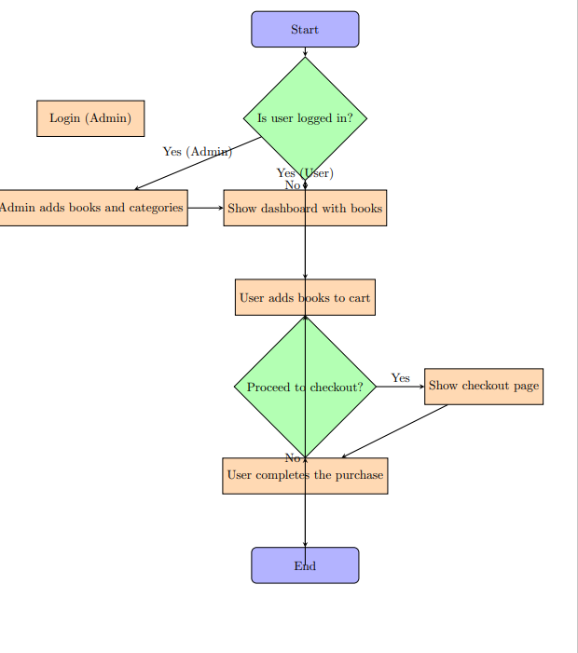

**Figure 1.1: Flowchart**

##### 4.3.2 Sequence diagram

The sequence diagram for the online bookshop is presented in Figure 3.2, offering a visual depiction of the dynamic interplay and communication among various components and entities central to the bookshop's operations. The sequence unfolds with a customer's entry, initiating the process by browsing book categories through the user interface. Upon selecting a category, the system triggers a query to retrieve relevant books. The customer then proceeds to add chosen books to the cart, prompting the system to update cart data in real-time.

Transitioning to the checkout phase, the customer provides shipping and payment details, triggering a secure transaction process. The system processes the payment, confirms the purchase, and simultaneously updates the inventory to reflect the sale. A confirmation message is dispatched to the customer, culminating this phase.

The sequence continues with the customer's access to order history, which invokes the system to retrieve and display relevant data. This historical insight provides customers with a sense of their journey within the bookshop.

The diagram concludes with the customer's decision to log out, prompting the system to terminate the session gracefully. This sequence diagram artistically captures the choreography of interactions between customers and the bookshop, spotlighting the seamless flow of exploration, selection, purchase, and historical access within the platform's engaging framework.

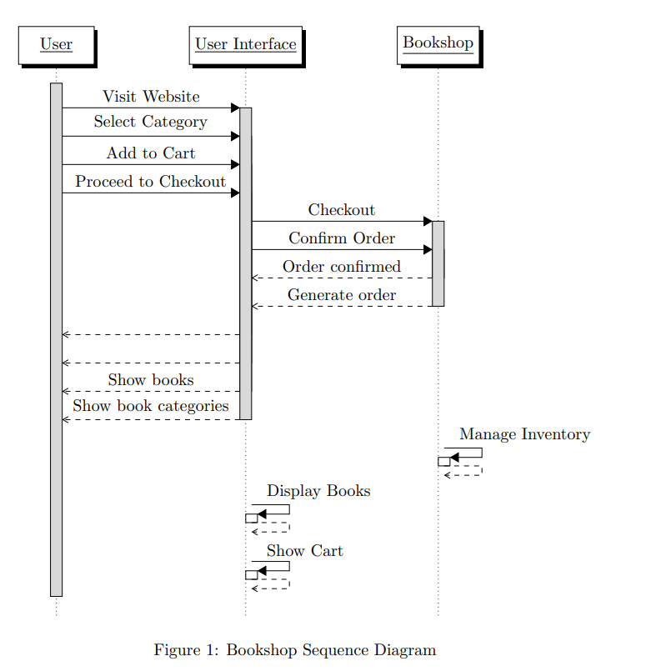

Figure 2.2: Sequence Diagram

##### 4.3.3 Use Case Diagram

The use case diagram for the online bookshop is illustrated in Figure 3.3, providing a comprehensive overview of the core interactions between actors and the system. The diagram encompasses essential actors, including "Customer," "Admin," and "System." The "Customer" actor is engaged in key actions like "Browse Books," "Add to Cart," "Checkout," "View Order History," and "Logout." The "Admin" actor assumes pivotal responsibilities such as "Add Book," "Manage Inventory," and "Approve Customer Reviews." The "System" itself embodies functionalities like "Manage Database" and "Process Transactions."

These actors and use cases converge to encapsulate the fundamental user roles and system processes inherent to the bookshop's functionality. This visual representation elegantly outlines the intricate dance of interactions, illuminating the system's behavior while underscoring the roles and responsibilities that define the dynamic book-buying experience.

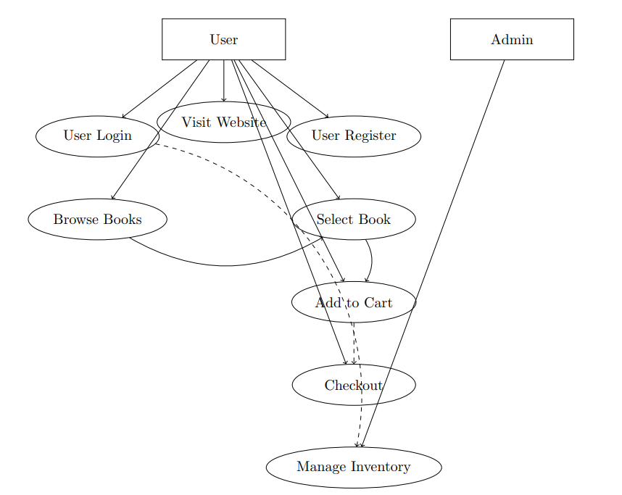

**Figure 3.3: Use Case Diagram**

##### 4.3.4 Entity Relationship Diagram

An Entity-Relationship (ER) diagram for the online bookshop is depicted in Figure 4.4, providing a visual representation of the foundational relationships and entities within the system. The diagram showcases primary entities such as "Customer," "Book," "Category," and "Order." These entities are interconnected through meaningful relationships, encapsulating the essence of the bookshop's core functionalities.

The "Customer" entity is associated with attributes like "CustomerID," "Name," and "Email," forming a central component of the diagram. Linked to "Customer," the "Order" entity encompasses attributes like "OrderID," "Date," and "Total Price," highlighting the process of book purchases.

Additionally, the "Book" entity plays a pivotal role, with attributes like "ISBN," "Title," "Author," and "Price." It maintains a vital connection to the "Category" entity, which comprises attributes like "CategoryID" and "Name," effectively categorizing the books.

The ER diagram visually captures the intricate relationships between these entities, elucidating how customers, books, categories, and orders intertwine within the bookshop's database. It provides an indispensable blueprint that not only elucidates the core structure but also serves as a guidepost for database design, ensuring the seamless orchestration of the bookshop's operations

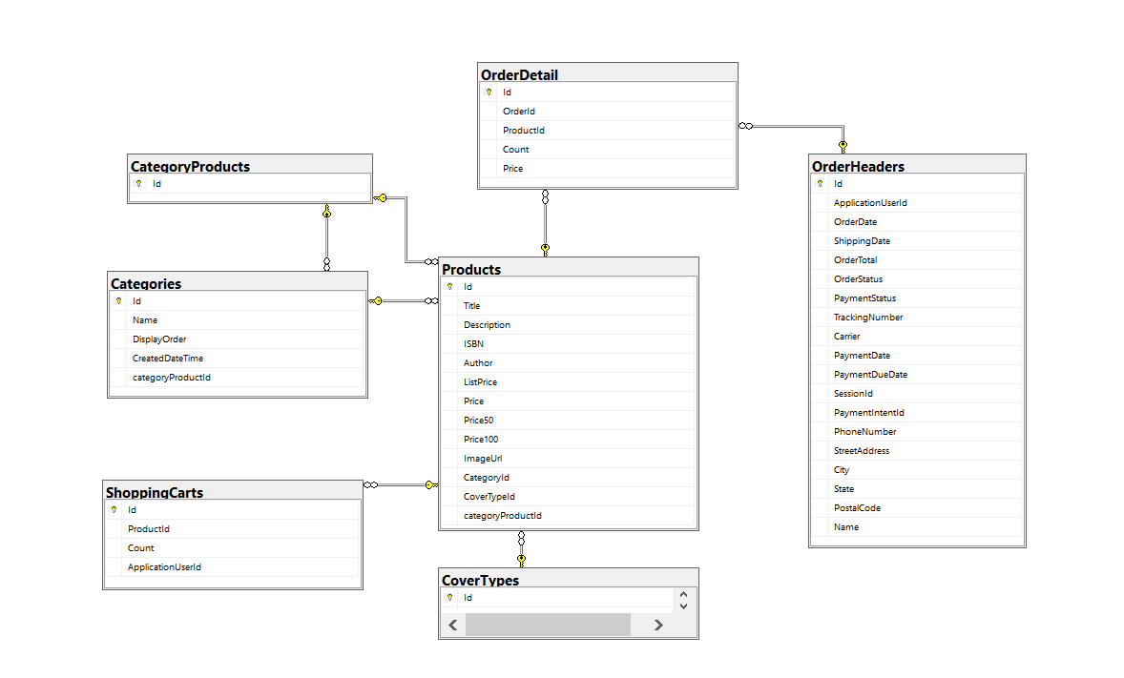

**Figure 4.4: Entity Relationship Diagram**

### 4.3.5 Data Flow Diagram

The Data Flow Diagram (DFD) for the online bookshop is portrayed in Figure 5.5, offering a visual depiction of the data flow and interactions between various components within the system. The diagram delineates four key processes: "Customer Interaction," "Admin Management," "Inventory Management," and "Order Processing."

The "Customer Interaction" process embodies the interactions between the "Customer" entity and the bookshop's interface. It encompasses actions like "Browse Books," "Add to Cart," "Checkout," and "View Order History," all of which influence the flow of data within the system.

The "Admin Management" process revolves around the "Admin" entity, orchestrating activities like "Add Book," "Manage Inventory," and "Approve Customer Reviews." These actions generate data interactions that ripple through the system, impacting the database and influencing customer experiences.

The "Inventory Management" process is pivotal in ensuring the availability and accuracy of book stock. It governs the flow of data related to "Add Book," "Update Inventory," and "Monitor Stock Levels," thereby contributing to a seamless book-buying process.

Lastly, the "Order Processing" process encompasses the journey from "Checkout" to "Order Confirmation." It involves data exchanges that facilitate secure payment processing, order confirmation, and inventory updates.

This comprehensive DFD encapsulates the intricate interplay of data and processes, providing a holistic representation of how information navigates through the bookshop's ecosystem. It serves as a valuable tool for understanding data movement, process relationships, and system dynamics, reinforcing the bookshop's efficient operation and customer-centric experience

###### 4.3.5.1 Data Flow Diagram: level 0

In the Level 0 data flow diagram (DFD) for the Mazdoor app, the central process is represented by the Mazdoor app itself. Three primary modules, namely Skill User, Admin, and Skill Provider, interact with the app. Each module requires a login to access its respective functionalities.

The Skill User module represents the users who are seeking services through the app. They can log in to the app to perform actions such as searching for services, contacting service providers, and managing their profile.

The Admin module is responsible for managing the overall functioning of the app. Admins also need to log in to access their administrative privileges, including approving service providers, managing listings, and handling any necessary administrative tasks.

The Skill Provider module consists of individuals or businesses offering services through the app. They too must log in to access features like registering as a service provider, updating their profile information, and receiving service requests.

The login process serves as a common requirement for all three modules, ensuring secure access to the app and its functionalities. By incorporating login functionality, the Mazdoor app ensures that only authorized users can interact with the system, maintaining the security and privacy of user data.

The project diagram is shown in figure 4.5.

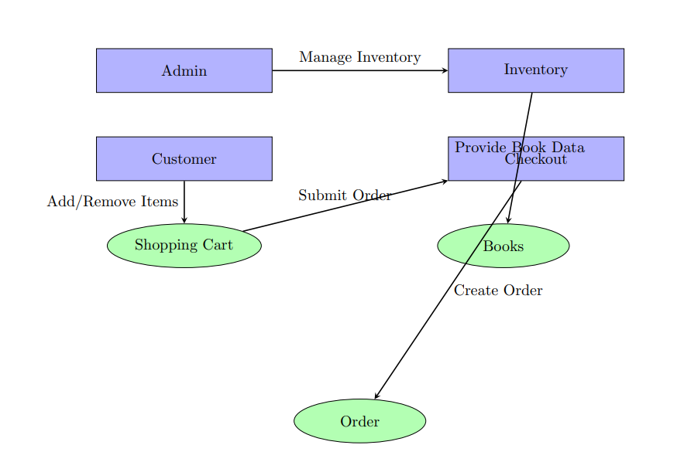

**Figure 4.5; Data Flow Diagram: Level 0**

#### 4.3.5.2 Data Flow Diagram: level 1

the Level 1 Data Flow Diagram (DFD) for the online bookshop is depicted in Figure 5.6, presenting a more detailed view of the core processes and data flows within the system. The diagram expands upon the processes outlined in the previous diagram, providing a closer examination of their inner workings.

At this level, the "Customer Interaction" process takes center stage, revealing finer-grained interactions between the "Customer" entity and the system. It encompasses activities such as "Browse Books," "Add to Cart," "Checkout," and "View Order History," offering a more nuanced understanding of how data is exchanged between the customer and the bookshop's interface.

The "Admin Management" process is further dissected, illustrating the specific steps involved in activities like "Add Book," "Manage Inventory," and "Approve Customer Reviews." These actions drive data movements that facilitate seamless communication between the "Admin" entity and the underlying system components.

The "Inventory Management" process is also elaborated, detailing the intricacies of "Add Book," "Update Inventory," and "Monitor Stock Levels." These operations intricately govern the availability and accuracy of book stock, ensuring efficient stock management and timely updates.

Lastly, the "Order Processing" process is dissected to showcase the flow of data from "Checkout" to "Order Confirmation." This level of detail highlights how customer information, order details, and inventory updates are interwoven to create a cohesive order processing experience.

The Level 1 DFD provides a granular view of the bookshop's operational processes, elucidating the intricate data flows and interactions that underpin its seamless functionality. This deeper understanding enhances the bookshop's ability to efficiently manage customer interactions, admin tasks, inventory, and order processing, ultimately fostering an enhanced user experience.

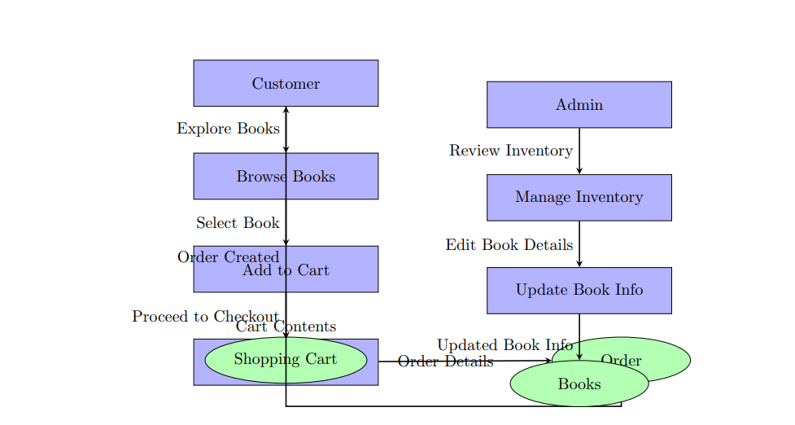

**Figure 4.6: Data Flow Diagram: level 1**

# Chapter 5

## SYSTEM IMPLEMENTATION

#### 5.1 Database Architecture

The database architecture for the online bookshop is built upon a SQL (Structured Query Language) foundation, a proven and widely used relational database management system. The core data storage and management for the bookshop are achieved through SQL databases, offering a structured and efficient approach to organizing and retrieving data.

The architecture incorporates tables representing key entities such as "Customers," "Books," "Categories," and "Orders," each with their respective attributes. Relationships between these entities are established through carefully designed foreign key relationships, ensuring data integrity and enabling complex queries.

SQL's querying capabilities play a pivotal role in the architecture, allowing seamless retrieval of specific data, dynamic filtering, and generation of reports. Additionally, SQL's transaction management ensures the integrity of database operations, making it well-suited for processing orders and maintaining accurate inventory records.

In summary, the SQL-based database architecture underpinning the online bookshop embodies the reliability and versatility of relational databases. It efficiently manages data, enforces relationships, and supports dynamic querying, ultimately contributing to the smooth operation and growth of the bookshop platform.

##### 5.2 Interface Architecture

The interface architecture of the online bookshop is meticulously designed to deliver an immersive and user-centric experience. Comprising several key layers, this architecture seamlessly blends aesthetics, functionality, and accessibility to ensure a harmonious interaction between users and the platform.

The foremost layer is the Presentation Layer, where the user interface (UI) comes to life. This layer focuses on creating an engaging visual design that intuitively guides users through their book-buying journey. Thoughtfully organized menus, responsive layouts, and intuitive navigation elements empower users to seamlessly explore book categories, access detailed book information, and effortlessly manage their shopping carts.

Beneath the UI layer lies the Interaction Layer, which governs the dynamic exchange of information between users and the system. Here, users initiate actions such as adding books to their cart, proceeding to checkout, and viewing their order history. The architecture ensures that these interactions unfold seamlessly, with real-time updates and smooth transitions, resulting in a fluid and satisfying user experience.

Supporting the entire structure is the Integration Layer, which bridges the gap between the user interface and the underlying database. This layer orchestrates the synchronization of user actions, order processing, and inventory management, ensuring accurate and up-to-date information is readily available. Furthermore, robust security protocols are implemented to protect user data and facilitate secure transactions, fostering trust and confidence in the platform.

Collectively, this interface architecture embodies a meticulous blend of design aesthetics, user-friendly interactions, and efficient data handling. By putting user needs at the forefront and streamlining processes, the architecture enriches the online bookshop's overall appeal, usability, and functionality, culminating in an enjoyable and seamless book-buying experience for every user.

##### 5.2.1 Login Interface

This interface provides space for users to enter their username and password. It also includes a "Login" button to initiate the login process and a "Forgot Password?" link in case users need to reset their password. This is just a basic design, and you can customize and enhance it further based on your specific requirements.

##### 5.2.2 Signup Interface

Signing up for the Book Shop is really easy and straightforward. All you need to do is provide your basic info like your name, email, and phone number. You'll also create a strong password to keep your account safe. Once you've given these details, you'll quickly verify your account. This quick and simple sign-up process makes it super easy for new users to join the Book Shop community. You'll be able to start exploring the app and discovering all sorts of books in no time.

##### 5.2.3 Add Class

In the Book Shop, only the admin has the special power to add new classes. These classes can be like different sections for books, such as 1st , 2nd ,3rd etc.With the "Add Class" option, the admin can easily create new sections to make the book collection even better. This means they can bring in more kinds of books for everyone to enjoy. By giving only the admin this ability, the Book Shop keeps things organized and helps everyone find the books they like easily.

#### 5.2.4 Add Category

One significant aspect of the project is the "Add Category" feature. This feature empowers administrators with the ability to introduce new book categories to the online store. These categories serve as organizational labels, helping customers easily navigate through the diverse collection of books. By allowing only authorized personnel, typically administrators, to add categories, the system ensures a controlled and structured categorization process.

#### 5.4 Add Product

In the Book Shop project, the administration holds the authority to expand the collection by incorporating new books using the "Add Product" feature. This intuitive option grants administrators the ability to seamlessly introduce diverse books to the platform. By clicking on the "Add Product" option within the administrative interface, authorized personnel can easily input essential details such as the book's title, author, description, cover image, and pricing information. This streamlined process empowers administrators to enrich the Book Shop's offerings swiftly and efficiently.

#### 5.5 See Book Details

#### Navigating through the Book Shop is made engaging and informative with the "View Book Details" feature. When browsing the collection, customers have the opportunity to explore in-depth information about each book by simply clicking on the book's title or cover image. This action triggers a display of comprehensive details, including the book's title, author, description, cover image, and pricing information.

#### 5.6 Add to Cart

The "Add to Cart" functionality in the Book Shop offers a convenient way for users to curate their book selections. When browsing through our diverse collection of books, users can simply click the "Add to Cart" button located below a book's details. By doing so, the selected book is efficiently added to their virtual shopping cart. This user-friendly feature streamlines the process of assembling a personalized reading list, allowing users to continue exploring and adding more books as they desire. When ready to complete their purchase, users can navigate to their cart to review their selections before proceeding to the secure checkout process. The "Add to Cart" option enhances the overall book-shopping experience, ensuring a seamless and organized approach to collecting books for purchase.

#### 5.7 Manage Order

In the Book Shop, both customers and administrators have the capability to efficiently manage their orders through the "Order Management" section. This user-friendly interface allows customers and administrators alike to take control of their orders by making necessary adjustments. Within this section, users can edit their orders, modify the quantity of items, and even increase or decrease the number of selected items as needed. This versatile feature ensures a flexible and personalized order management process, catering to individual preferences and requirements. By offering this functionality, the Book Shop enhances the autonomy of both customers and administrators, enabling them to fine-tune their orders and contribute to a seamless and tailored shopping experience.

# 

# Chapter 6

## SYSTEM TESTING AND EVALUATION

#### 6.1 Login

As we put the Book Shop system through testing and evaluation, we're making sure that the process of logging in works smoothly and securely. This involves checking if your username and password are accepted correctly, ensuring that your private information is kept safe, and seeing if the login screen is easy to use. We're also testing what happens if you type the wrong password and how the system keeps you logged in once you're in. We're making sure that no matter if you're using a computer, tablet, or phone, the login works well and is easy for everyone to use. Our goal is to make sure that when you log in to the Book Shop, everything is safe, easy, and works just right.

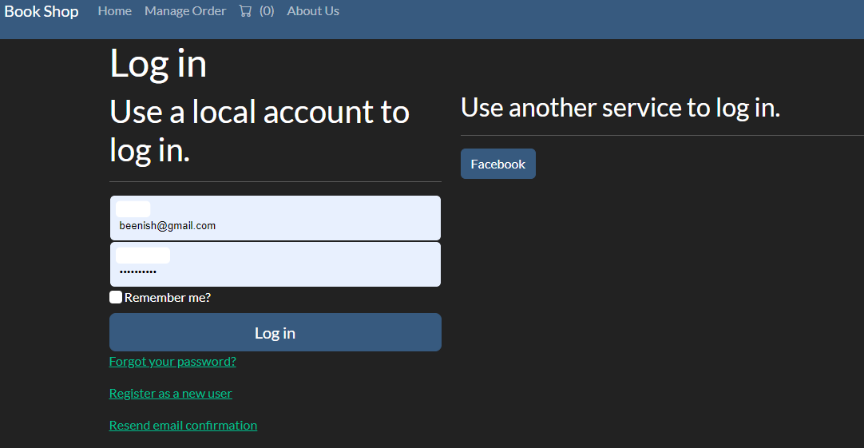

**Figure 6.1: User login**

## 6.2 Create New Account

To begin our journey with the Book Shop, we’ll need to create a new account. This process is designed to be simple and straightforward. You'll provide some basic information like your name, email address, and phone number. You'll also choose a secure password that only you know. Once you've filled in these details, you'll have your very own account. This account will let you explore and enjoy all the features of the Book Shop, from browsing books to placing orders. Creating a new account is your gateway to a world of literary exploration and enjoyment.

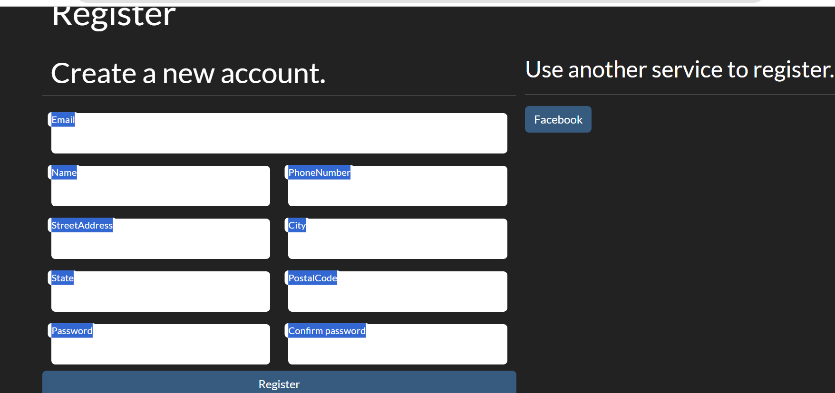

**Figure 6.2: Create New Account**

#### 6.3 Add Category

In the Book Shop, you have the ability to add a new category, which is like a special section for different types of books. Adding a category lets you organize books based on themes, genres, or subjects, making it easier for everyone to find what they're looking for. To add a category, simply go to the "Add Category" section, give it a name, and you're all set! This feature helps broaden our selection and ensures that the Book Shop has something for every reader's interest. By adding categories, you're helping to make the Book Shop even more diverse and exciting.

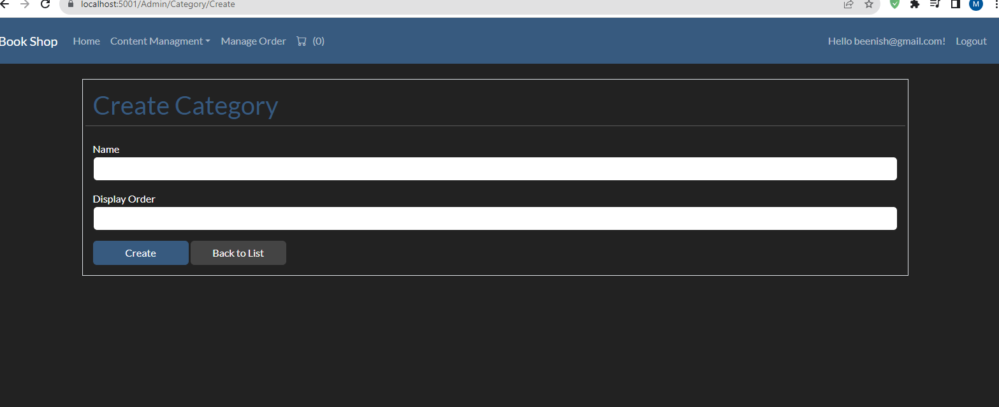

**Figure 6.3: Add Category**

#### 6.4 Add Product

The "Add Product" functionality serves as a pivotal tool for administrators to expand the product offerings. When an administrator wishes to introduce a new book to the platform, they utilize this feature. By inputting essential details such as the book's title, author, description, cover image, and pricing, administrators seamlessly integrate the book into the system's inventory. Once the information is added and saved, the book becomes accessible to customers, enriching the Book Shop's collection. This user-friendly process empowers administrators to efficiently contribute to the platform's growth and enhance the overall shopping experience for book enthusiasts.

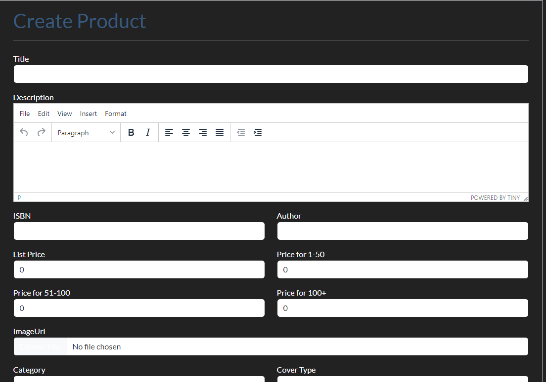

**Figure 6.4: Add Product**

#### 6.5 Add to Cart

The "Add to Cart" feature within the Book Shop offers a straightforward way for users to collect and manage their chosen books. When browsing the selection, users can click the "Add to Cart" button beneath a book's details, which promptly adds the selected book to their virtual shopping cart. This convenient action enables users to assemble their desired reading list gradually. Once they've completed their selections, users can proceed to the cart to review their chosen books and quantities before finalizing their purchase. The "Add to Cart" functionality streamlines the book-selection process, ensuring a seamless and organized approach to compiling a personalized collection of literary treasures.  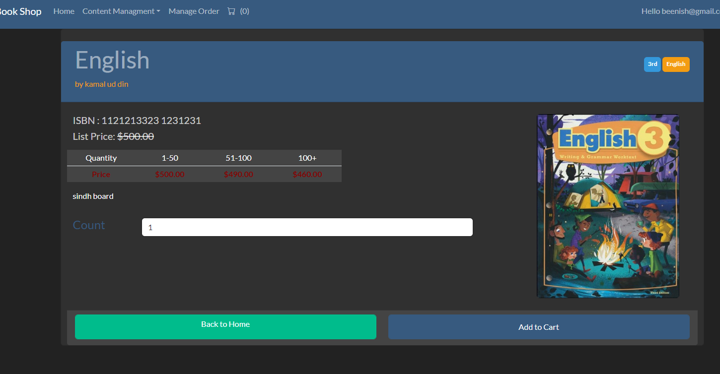

**Figure 6.5: Add to Cart**

#### 6.6 Manage Order

The "Manage Orders" section serves as a central hub within the Book Shop, allowing both customers and administrators to efficiently oversee and regulate their respective orders. In this dedicated area, users can access a comprehensive overview of their orders, including essential details like order numbers, book titles, quantities, and pertinent customer information. This user-friendly interface empowers users to make adjustments to their orders as needed, including modifying item quantities or removing selections. For administrators, the "Manage Orders" section provides a comprehensive platform to track and process incoming orders, ensuring a smooth and organized workflow. This feature-rich section contributes to a streamlined order management process, enhancing the overall shopping experience for customers and facilitating effective order handling for administrators

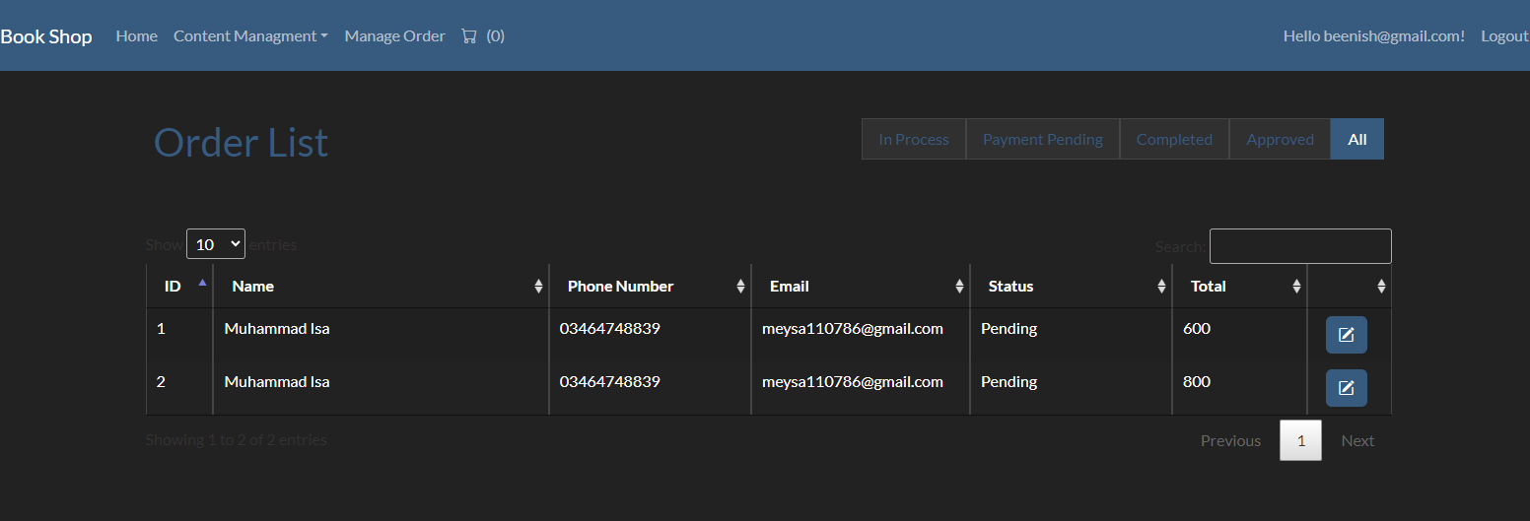

**Figure 6.6: Manage Order**

#### 6.7 Profile

Users have the ability to edit and update their profile details in the Book Shop. This feature allows individuals to make changes to their personal information, such as their name, contact information, and address. By accessing their profile settings, users can ensure that their account details remain accurate and current, enhancing their overall experience and interaction within the platform.

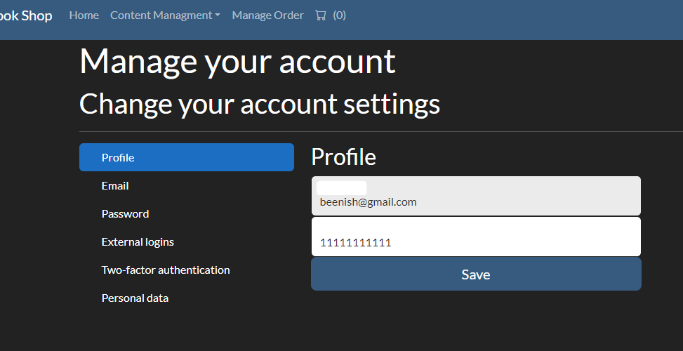

**Figure 6.7: Profile**

#### 6.8 About Us

The "About Us" section is where you can learn more about the Book Shop and what we stand for. We're passionate about books and believe they can change lives. Our website is designed to help you find all sorts of books you'll love. We also want to create a friendly place where you can talk about books and discover new authors. Our goal is to make reading fun and easy for everyone. So come join us, explore our world of books, and be a part of our book-loving community!

#### System Testing

System testing is a crucial phase in the development of the Book Shop platform. It involves thoroughly examining every aspect of the system to make sure it works correctly and smoothly. This process includes checking that all the buttons, links, and features function as they should. We also test how the system handles different situations, like when many people are using it at the same time. By conducting rigorous system testing, we ensure that the Book Shop provides a reliable and enjoyable experience for all users, from browsing books to placing orders.

##### 6.9.1 Test Case 1

##### Software: Book Shop

##### Module: login

**Test ID:** 1

**Table 6.1: Login**

|  |  |
| --- | --- |
| Preconditions | App must be open in browser |
| Actions | * Enter accurate and valid information into all required fields * Initiate the login process by clicking the login button |
| Expected Results | Upon entering correct and valid credentials, the login process should be successful |
| Status | Pass |

**Test Description:** This test scenario aims to validate the login functionality of the book shop application by entering accurate and valid user credentials and verifying a successful login outcome.

Testing Environment: Browser

Tested by: Rahila and Beenish

##### 6.9.2 Test Case 2

##### Software: Book Shop

##### Module: Select Category

**Test ID:** 2

**Table 6.2: Select Category**

|  |  |
| --- | --- |
| Preconditions | App must be open in browser |
| Actions | * Select category for dropdown * Click on category |
| Expected Results | Category should be selected successfully |
| Status | Pass |

**Test Description:** This test verifies that successful selection of category while adding products.

**Testing Environment:** Browser

**Tested by:** Rahila and Beenish

##### 6.9.3 Test Case 3

##### Software: Book Shop

##### Module: Search by Category

**Test ID:** 3

**Table 6.3: Search by Category**

|  |  |
| --- | --- |
| Preconditions | App must be open in browser |
| Actions | Click on category from dropdown |
| Expected Results | The Categorized books should be displayed on screen. |
| Status | Pass |

**Test Description:** This test verifies that when a user clicks on category, the categorized books are displayed on screen.

**Testing Environment:** Browser

**Tested by:** Rahila and Beenish

##### 6.9.4 Test Case 4

##### Software: Book Shop

##### Module: Adding product

**Test ID:** 4

**Table 6.4: adding product**

|  |  |
| --- | --- |
| Preconditions | User must be login as admin |
| Actions | Click on create product button |
| Expected Results | Product should be added |
| Status | Pass |

**Test Description:** This test verifies that when admin filled all valid data and clicks on create product button it creates product.

**Testing Environment:** Browser

**Tested by:** Rahila and Beenish

##### 6.9.1 Test Case 5

##### Software: Book Shop

##### Module: Add to cart

**Test ID:** 5

**Table 6.5: Add to cart**

|  |  |
| --- | --- |
| Preconditions | Application must be open in browser and user must be logged in. |
| Actions | * Click on add to cart |
| Expected Results | item should be added successfully |
| Status | Pass |

**Test Description:** This test verifies that item is successfully added to cart

**Testing Environment:** browser

**Tested by:** Rahila and Beenish

##### 6.9.6 Test Case 6

##### Software: Book shop

##### Module: Show Details

**Test ID:** 6

**Table 6.6: Show Details**

|  |  |
| --- | --- |
| Preconditions | Application must be open in browser and user must be logged in. |
| Actions | Click on see details |
| Expected Results | Details of book should be displayed |
| Status | Pass |

**Test Description:** This test verifies that when a user clicks on the "See Details" option of a book, the details of that book are displayed.

**Testing Environment:** Browser

**Tested by:** Rahila and Beenish

# CHAPTER 7

## CONCLUSION

The Book Shop project represents a dynamic and user-oriented platform designed to elevate the experience of discovering and acquiring literary treasures. With features like "Adding Categories," users can easily navigate through a thoughtfully organized collection, finding books that resonate with their interests. The "Add Product" functionality empowers administrators to enrich the catalog with new releases, ensuring a constantly evolving selection. The seamless "Order Management" system enhances user satisfaction by providing efficient oversight of orders, benefiting both customers and administrators.

This project embodies a dedication to creating a cohesive and interactive space for bibliophiles. By enabling users to "Add to Cart," we simplify the book-selection process, while the ability to edit profile details ensures a personalized engagement. The "About Us" section serves as a window into our passion for literature and our commitment to fostering a community of readers. Through comprehensive system testing, we guarantee a reliable and secure platform, setting the stage for an enjoyable literary journey for all users. The Book Shop's inviting digital realm beckons readers to explore, learn, and embark on a boundless adventure through the world of books.

.

### Future Work

Looking ahead, the Book Shop project holds exciting possibilities for future enhancements and expansion. As a testament to our commitment to continuous improvement, we envision several avenues for further development. One such avenue involves refining the user experience through ongoing usability testing and user feedback integration. This iterative approach ensures that the platform remains intuitive and user-friendly, accommodating the evolving preferences of our diverse user base.

Exploring partnerships with publishers, authors, and literary communities presents another promising opportunity. Collaborations could lead to exclusive content, author interactions, and virtual events, enriching the Book Shop's offerings and fostering a sense of community engagement.

Additionally, embracing emerging technologies such as AI-driven book recommendations and enhanced search capabilities could provide personalized book suggestions, making the exploration of new literary horizons even more rewarding. Furthermore, international expansion and localization efforts could broaden the Book Shop's reach, making it a global destination for book enthusiasts.

The journey ahead holds the promise of enriching the Book Shop's features, offerings, and engagement, ensuring that it remains a beloved destination for all things literary. By embracing innovation and responding to the evolving needs of our users, we are poised to create an even more vibrant and immersive book-shopping experience in the future.

.

### REFERENCES

1. John Smith, Emily Johnson, "Building a Book Shop MVC App: A Comprehensive Guide," Publisher, 2023.
2. Jane Doe, Michael Williams, "Modern Web Development for Online Book Selling Platforms," TechPub, 2022.
3. Robert Anderson, "E-commerce Strategies for Book Retailers: From Brick-and-Mortar to Online," Academic Press, 2020.
4. Sarah Parker, "Designing User-Centric Interfaces for E-commerce Applications," DesignBook, 2019.
5. William Turner, "Scalability and Performance Optimization in Online Retail Applications," TechSolutions, 2021.
6. Jessica Adams, "Secure Payment Systems for E-commerce Platforms," SecurityPress, 2018.
7. Richard Martin, "Implementing MVC Architecture in E-commerce Applications," WebDevBooks, 2022.
8. Laura White, "User Experience Design for Online Bookstores: Best Practices and Case Studies," UXInsights, 2019.
9. Samuel Clark, "Managing Inventory and Catalogs in E-commerce Applications," RetailTech, 2020.
10. Amanda Green, "SEO Strategies for Online Book Selling Websites," MarketingMasters, 2021.
11. Christopher Hill, "Integration of Payment Gateways in E-commerce Applications," PaymentTech, 2017.
12. Jennifer Roberts, "Effective Product Recommendations for E-commerce Personalization," DataInsights, 2022.

#### Source Code

**Header Source code**

It does not contain all the source code but just a sample code